Penetration Test Report: Damn Vulnerable Web Application (DVWA)

Executive Summary
On July 15, 2025, at 11:12 AM EAT, a penetration test was conducted on the Damn Vulnerable Web Application (DVWA) in Low security mode as part of Project 1: Web Application Penetration Testing Lab. Due to OWASP ZAP’s Active Scan hanging, testing relied on manual exploitation and sqlmap. Critical vulnerabilities—SQL injection, cross-site scripting (XSS), command injection, and file inclusion—were identified, posing severe risks to data confidentiality, integrity, and system security. Screenshots provide visual proof of successful exploitation, enhancing credibility for this portfolio report and resume. Recommendations include parameterized queries, input sanitization, and Content Security Policy (CSP).

Scope
- Target: DVWA at http://localhost:8080 (Docker container 3faf72a0a45e).
- Security Level: Low.
- Tools: Manual testing, sqlmap.
- Date: July 15, 2025.
- Time: 11:12 AM EAT.
- Tester: Gladwell Wanjiku.

Findings

1. SQL Injection (Critical)
- Description: Unsanitized input in the SQL Injection module allows arbitrary SQL query execution.
- Location: http://localhost:8080/vulnerabilities/sqli/.
- Proof of Concept:
Manual: Input 1' OR '1'='1 retrieved multiple user records (e.g., admin, gordonb).
Screenshot:
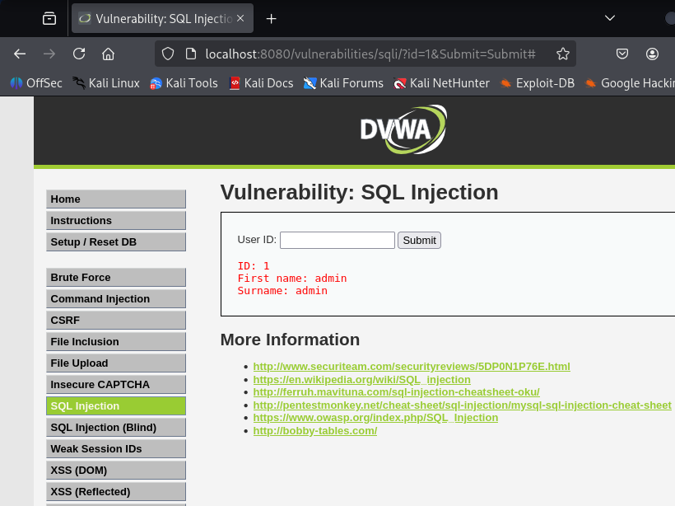
sqlmap: Command:
sqlmap -u "http://localhost:8080/vulnerabilities/sqli/?id=1&Submit=Submit" --cookie="security=low; PHPSESSID=your_session_id" --dump
Output (in sqlmap_output.txt):
Table: users
+---------+----------------------------------+
| username| password_hash |
+---------+----------------------------------+
| admin | 5f4dcc3b5aa765d61d8327deb882cf99 |
| gordonb | e99a18c428cb38d5f260853678922e03 |
+---------+----------------------------------+
- Impact: Unauthorized access to the entire database, exposing user credentials.
- Recommendation: Use parameterized queries. Implement strict input validation.

2. Cross-Site Scripting (XSS) Reflected (High)
- Description: Unfiltered input in the XSS Reflected module allows client-side script execution.
- Location: http://localhost:8080/vulnerabilities/xss_r/.
- Proof of Concept:
  - Input: <script>alert('XSS Test')</script> triggered a JavaScript alert.
  - Screenshot:
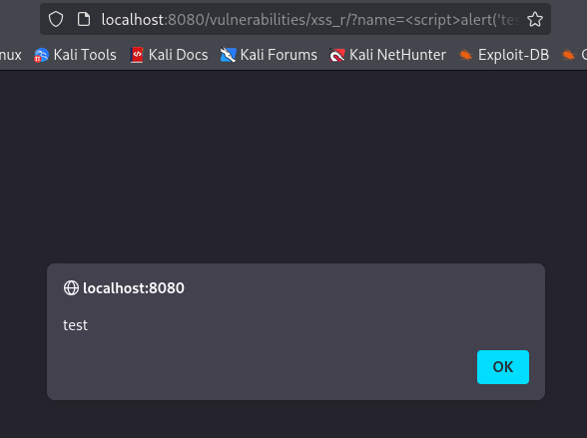
- Impact: Session cookie theft, user redirection, or malware delivery.
- Recommendation: Implement Content Security Policy (CSP). Sanitize and escape inputs.

3. Command Injection (Critical)
- Description: Unsanitized input in the Command Injection module allows arbitrary system command execution.
- Location: http://localhost:8080/vulnerabilities/exec/.
- Proof of Concept:
  - Input: 127.0.0.1 && whoami returned www-data.
  - Screenshot:
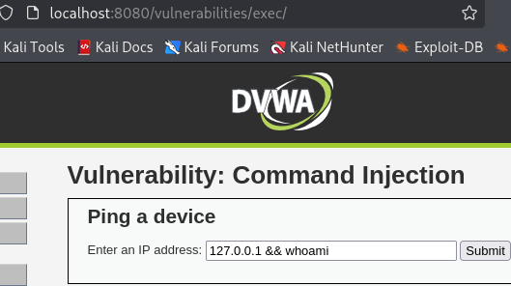
- Impact: Full system compromise, enabling command execution and potential privilege escalation.
- Recommendation: Validate and sanitize inputs. Avoid direct command execution.

4. File Inclusion (High)
- Description: The File Inclusion module permits access to arbitrary server files via path traversal.
- Location: http://localhost:8080/vulnerabilities/fi/.
- Proof of Concept:
  - Input: ../../etc/passwd displayed /etc/passwd contents.
  - Screenshot:
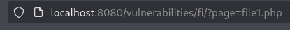
- Impact: Exposure of sensitive system files, facilitating further attacks.
- Recommendation: Use allowlists for file paths. Restrict file access.

Methodology
- Manual Testing: Exploited vulnerabilities in DVWA’s Low security mode using crafted inputs in Firefox.
- sqlmap: Automated SQL injection to dump the user table.
- Environment: Kali Linux, DVWA Docker container (3faf72a0a45e), Firefox.
- Challenges: OWASP ZAP Active Scan failed due to hanging, likely from proxy or resource issues, prompting manual and sqlmap approaches.

DVWA in Low security mode is highly vulnerable to SQL injection, XSS, command injection, and file inclusion, with significant security risks. Screenshots provide concrete evidence of exploitation, suitable for a professional portfolio. Immediate remediation is critical to secure the application.

Recommendations
- Input Validation: Sanitize all user inputs.
- Parameterized Queries: Prevent SQL injection.
- Content Security Policy: Mitigate XSS risks.
- File Path Restrictions: Use allowlists for file inclusion.
- Secure Configuration: Harden DVWA and Docker environment.

Artifacts
- Report: dvwa_pentest_report.md
- Screenshots: screenshots/ (sql_injection_manual.png, sqlmap_screenshot.png, xss_alert.png, command_injection.png, file_inclusion.png)
- sqlmap Output: sqlmap_output.txt

